SIMPLE COMMUNITY LENDING LIBRARY
@CREATIVITY THINK (9483175986/7019689991)

ABSTRACT:
Simple Community Lending Library is a web-based application designed to help communities manage shared items such as books, tools, gadgets, and other resources. The system allows users to browse available items, request to borrow them, join waitlists, and receive reminders for returns. Administrators can approve or deny requests, track overdue items, categorize items, and monitor usage analytics. Using Django REST Framework for backend APIs and React for frontend UI, the platform provides a seamless digital borrowing experience for apartments, office communities, hostels, and similar groups..

INTRODUCTION OF THE PROJECT:
In many residential and office communities, shared items such as books, equipment, or tools are used by multiple individuals. Manual tracking of borrowed items often leads to confusion, loss, or mismanagement. The Simple Community Lending Library offers a centralized, digital system where users can easily borrow and return items while admins maintain control through dashboards and analytics.
The application streamlines lending operations by automating approvals, reminders, usage tracking, and feedback collection, ensuring efficient community item management..

PROJECT OBJECTIVES:

• Maintain a digital catalog of shared items
• Allow users to browse items and request borrowing
• Support borrow/return operations with proper tracking
• Send reminders for overdue items
• Manage waitlists for popular or unavailable items
• Provide item condition feedback after return
• Enable admins to approve, deny, or monitor borrow requests
• Offer analytics such as usage stats per category or item
• Export logs for community-level reports

PROBLEM OF THE STATEMENT:
Communities often struggle to manage shared items due to manual processes. Borrowed items might go missing, records may be inaccurate, and no data analytics exist for usage trends. The lack of reminders leads to overdue returns and misuse. This project solves the inefficiencies by providing a digital library system where all borrow/return activities, approvals, reminders, and records are handled systematically..

MOTIVATION OF THE PROJECT:
• To simplify item lending in community spaces
• To reduce item loss or overdue returns through structured tracking
• To eliminate manual record-keeping
• To provide data insights for improving inventory and usage
• To offer a transparent borrowing experience with history tracking
• To support shared resource culture in communities

BLOCK DAIGRAM OF PROJECT:

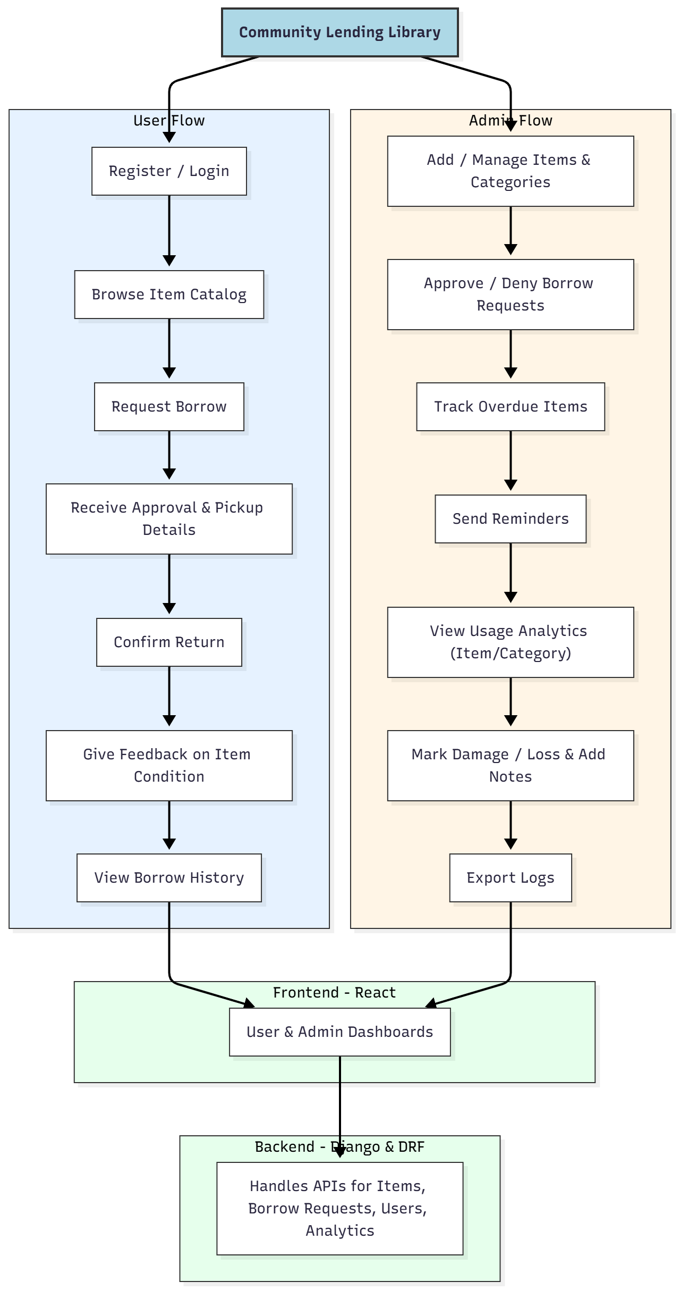

WORKING OF THE PROJECT:
Users begin by registering or logging into the system. They can browse the shared item catalog, request items to borrow, and receive approval from administrators along with pickup instructions. Once the item is returned, users confirm the return and optionally provide feedback regarding item condition.
Admins manage the inventory by adding new items, updating categories, and monitoring their availability. They receive borrow requests, approve or deny them, and track overdue returns. The system automatically sends reminders to users for late items. Analytics provide insights regarding frequently borrowed items, usage rates, and category trends. Admins can mark items as damaged or lost and export logs when required..

SOFTWARE REQUIREMENT:
- Backend:
  - Python 3.x
  - Django
  - Django REST Framework
  - SQLite/PostgreSQL
- Frontend:
  - Node.js and npm
  - React.js
  - Axios
- Development Tools:
  - Visual Studio Code
  - Postman (for testing APIs)
  - Git/GitHub (for version control)
- Server/Deployment (Optional):
  - Gunicorn, Nginx, or Heroku/AWS for hosting

ADVANTAGES OF THE PROJECT:

• Eliminates manual item tracking
• Ensures timely returns with automated reminders
• Prevents misuse of shared items through approval workflows
• Supports organized categorization of items
• Provides transparency with complete borrow history
• Offers insightful analytics for community decision-making
• Reduces resource loss through condition feedback and damage marking

APPLICATIONS OF THE PROJECT:
• Residential apartments
• Corporate office communities
• Hostels and dormitories
• Shared living spaces
• College clubs and community groups
• Small libraries or tool-sharing groups

REFERENCES:

- Django REST Framework Documentation — Django Software Foundation. Django Documentation. Available: https://docs.djangoproject.com/
- Django REST Framework. DRF Documentation. Available: https://www.django-rest-framework.org/
- React. React Official Documentation. Available: https://reactjs.org/docs/getting-started.html
- Redux. Redux Documentation. Available: https://redux.js.org/introduction/getting-started
- PostgreSQL Global Development Group. PostgreSQL Documentation. Available: https://www.postgresql.org/docs/
- MySQL. MySQL Reference Manual. Available: https://dev.mysql.com/doc/
- Git. Git Documentation. Available: https://git-scm.com/doc
- Node.js. Node.js Documentation. Available: https://nodejs.org/en/docs/
- Axios. Axios Documentation. Available: https://axios-http.com/docs/intro
- Socket.io Documentation – https://socket.io/docs/

